Fitness tracker

Submitted By:

Rhea Gracy – 2460430 emails: rhea.gracy@btech,christuniversity.in

Jessica Nalini Paully – 2460377 emails: jessica.nalini@btech.christuniversity.in

Angela Elizabeth Domingo *–* 2462033 emails: angela.elizabeth@btech.christuniversity.in

**Course**: Front End UI/UX Development

**Instructor Name**: Dhiraj Alate

**Institution:** Christ University Kengeri

**Date of Submission**: 12-08-2025.

**Abstract:** This project involves designing and developing a Fitness Tracker Dashboard that enables users to log their daily workouts, monitor progress, and set personal fitness goals. The dashboard provides interactive visualizations for workout trends, allowing users to track their improvements over time. The main goal of the project is to encourage healthy habits by providing a user-friendly, responsive, and intuitive interface. Core technologies used include HTML, CSS, JavaScript, Bootstrap, jQuery, and Chart.js. The final outcome is a functional dashboard that helps users effectively plan and analyze their fitness routines, with potential for future enhancements like backend integration and real-time data syncing.

**Objectives:**

* Design an intuitive dashboard interface for logging workouts.
* Implement a progress tracking system using interactive charts for visualizing performance.
* Allow users to set weekly or monthly fitness goals and track progress towards them.
* Ensure a fully responsive layout that works on desktop, tablet, and mobile devices.
* Apply Chart.js to create dynamic and visually appealing charts to represent fitness data.
* Promote user engagement by combining usability, interactivity, and aesthetic design principles.

**Scope of the project:**

The Fitness Tracker Dashboard focuses primarily on front-end web development. It allows users to:

* Log workouts with details such as type of exercise, duration, and calories burned.
* Visualize progress through charts to analyze improvements over time.
* Set and monitor personal fitness goals to encourage consistency.

Boundaries:

* No backend or database integration is included; data is not persisted after refresh.
* Authentication or user-specific profiles are not implemented.
* Designed as a prototype for demonstrating the concept and interface design.

**Tools & Technologies Used:**

| **Tool / Technology** | **Purpose** |
| --- | --- |
| HTML5 | Structure and semantic layout of the dashboard. |
| CSS3 | Styling, layout management, and responsive design. |
| JavaScript | Interactivity, dynamic chart updates, and data handling. |
| Bootstrap | Mobile-first responsive design and grid system. |
| jQuery | Simplified DOM manipulation and event handling. |
| Chart.js | Rendering interactive charts to visualize fitness progress. |
| VS Code | Primary code editor used for development. |
| Chrome DevTools | Debugging, testing, and ensuring responsive behavior. |

# Key Features:

* **Workout Log:** Users can record daily workouts including type, duration, and calories burned.
* **Progress Chart:** Graphical representation of workout data over time using bar and line charts.
* **Goal Setting:** Users can set weekly or monthly fitness targets and track progress visually.
* **Responsive Layout:** Dashboard adapts seamlessly across desktop, tablet, and mobile devices.
* **User-Friendly Interface:** Clean, simple navigation and dashboard design for easy access to information.

**Challenges Faced & Solutions:**

* **Challenge:** Representing fitness data clearly and visually engaging.  
  **Solution:** Implemented Chart.js for interactive and dynamic charts.
* **Challenge:** Ensuring charts and dashboard elements remained responsive.  
  **Solution:** Used Bootstrap grid system and media queries to maintain layout consistency.
* **Challenge:** Designing a dashboard that is simple yet effective.  
  **Solution:** Applied minimal UI principles, consistent colour themes, and logical layout.
* **Challenge:** Updating workout logs dynamically without a backend.  
  **Solution:** JavaScript functions manage updates to logs and charts in real-time.

**Outcomes:** The project successfully created a functional Fitness Tracker Dashboard that allows workout logging, goal tracking, and visualization of progress. The dashboard is responsive, interactive, and visually appealing, demonstrating effective application of front-end technologies. It serves as a prototype for a real-world fitness application and helps users track their fitness routines in an organized manner.

**Future Enhancements:** Integration with a backend database to store user data persistently.

User authentication and profile management for personalized dashboards.

Integration with fitness devices or APIs for real-time data syncing.

Notifications and reminders for workouts to improve adherence.

Customizable themes including light and dark modes.

Ability to export progress reports as PDF or share via email/social media.

**Sample Code:**

HTML Example: here are few parts of the code that play a key role in formatting our Fitness Tracker: 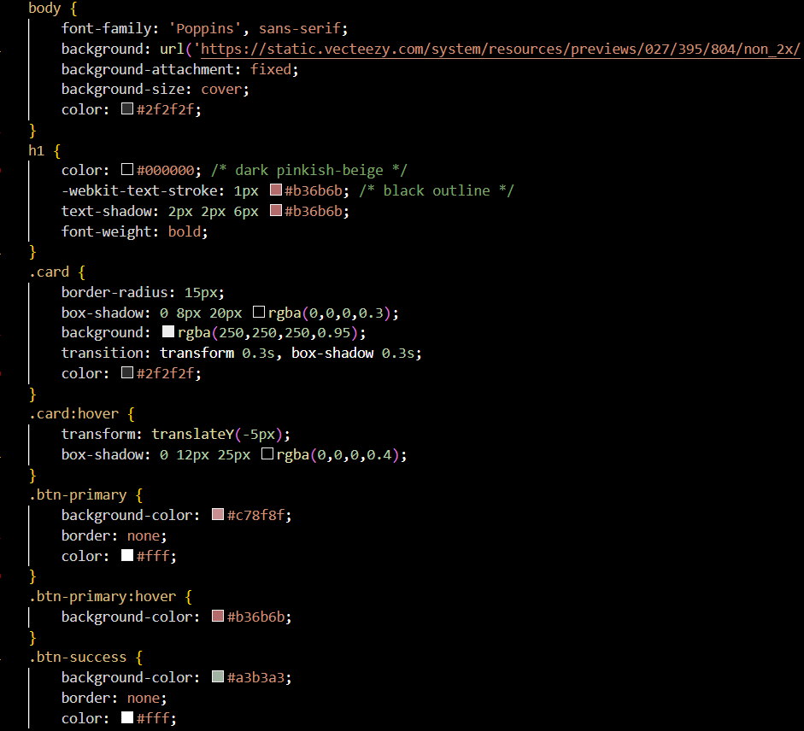

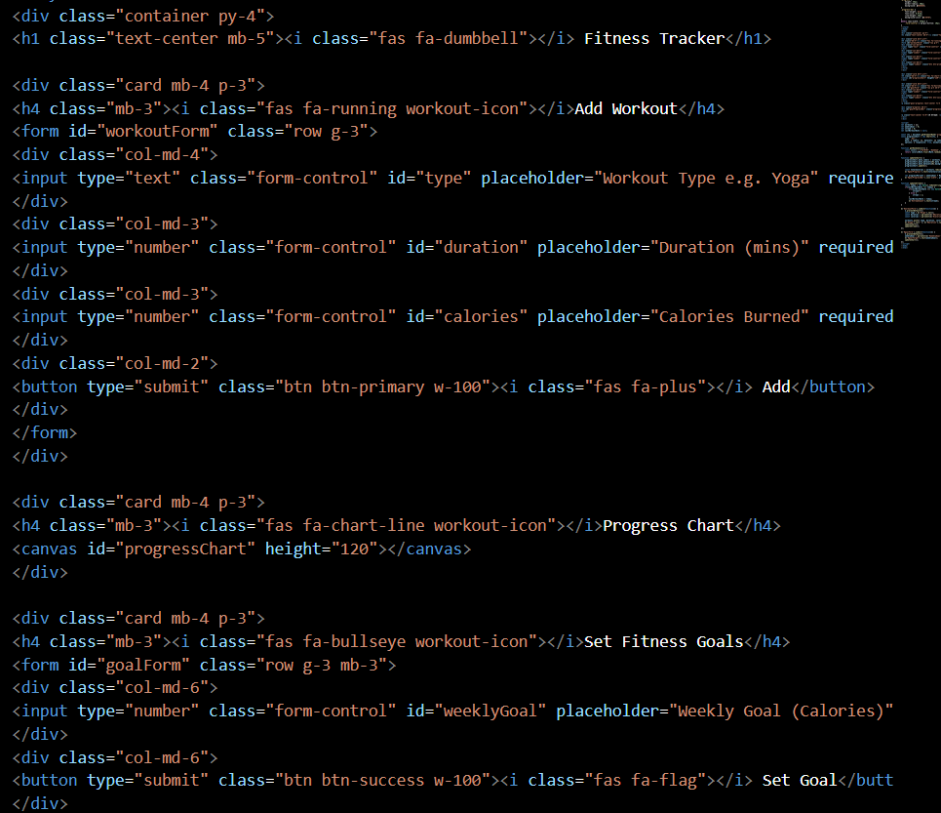

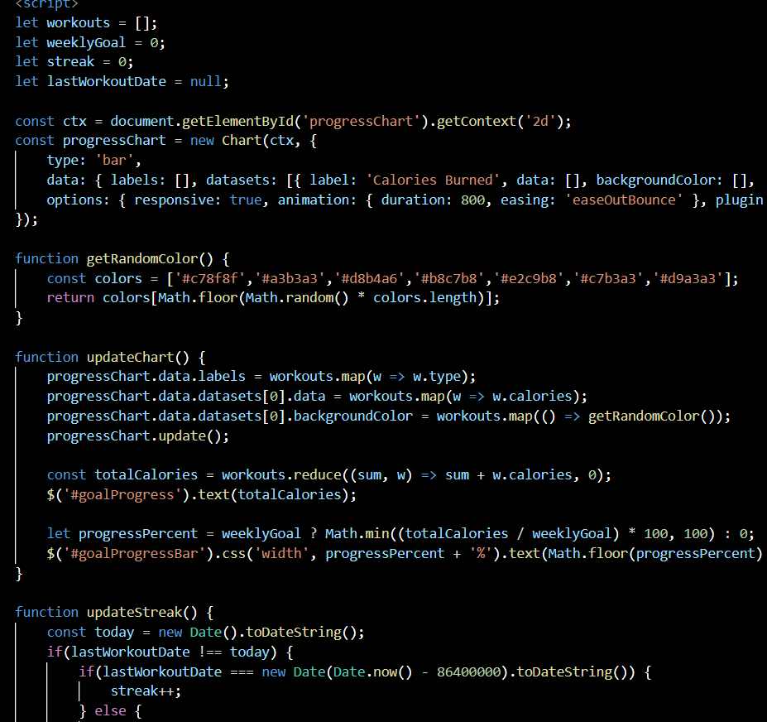

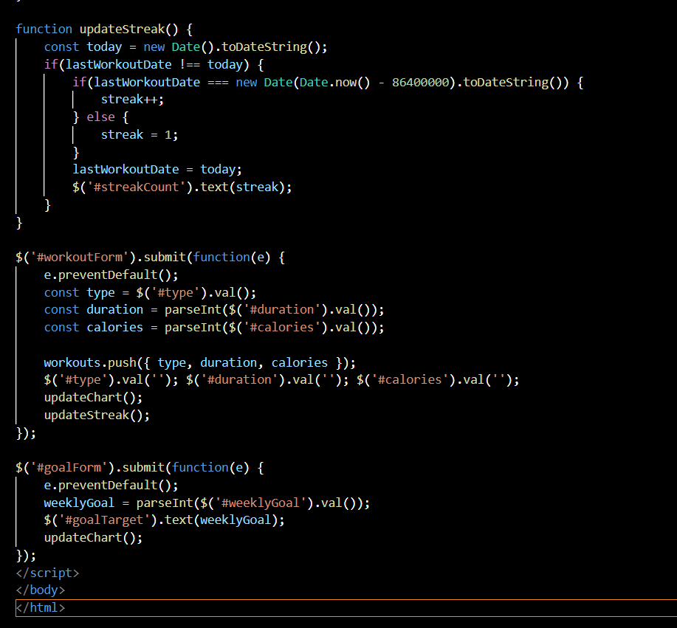

**Screenshots of Final Output:**

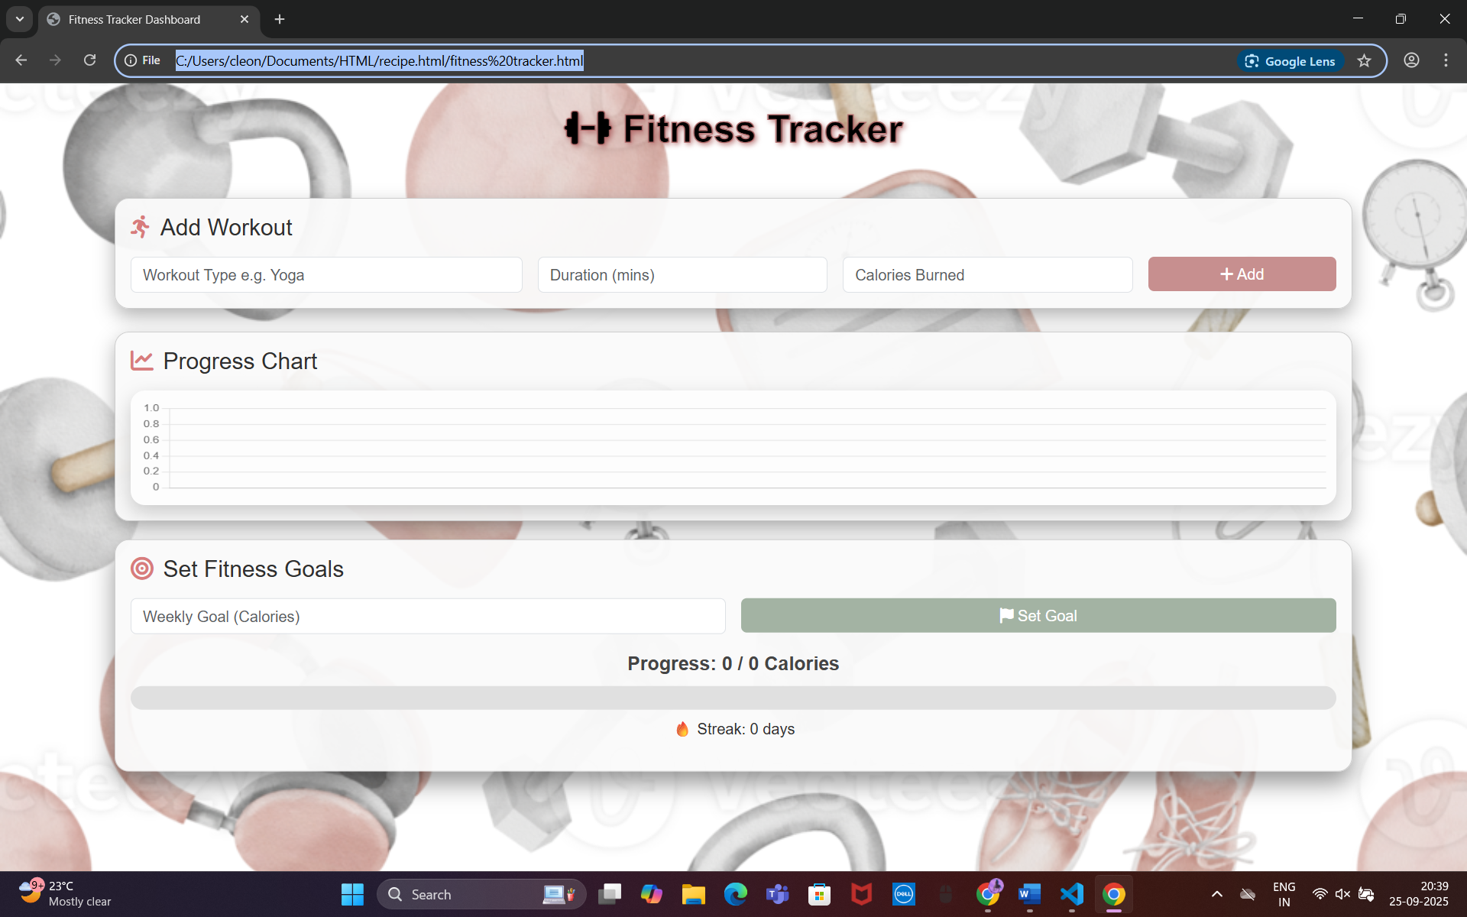

**Conclusion:** The Fitness Tracker Dashboard project strengthened our skills in front-end development, responsive design, and data visualization. By combining interactive charts with a user-friendly layout, we gained practical insights into creating engaging web applications that promote healthy habits. This project demonstrates the importance of usability, responsive design, and visual hierarchy in building modern web dashboards, and provides a strong foundation for future enhancements involving backend integration and real-time features.

**References:**

* L&T LMS: <https://learn.lntedutech.com/Landing/MyCourse>